GRANARD MUNICIPAL DISTRICT

Corporate Affairs,
Aras an Chontae,
Please note Time of Meeting – 3.00 p.m. LONGFOIRT.

21st June 2016.

To: Each Member of the Granard Municipal District.

A Chomhairleoir,

You are requested to attend the Annual Meeting of the Granard Municipal District to be held in Granard Community Library, on Tuesday, 28th June 2016 at 3.00 p.m. to transact business, as set out on the Agenda hereunder.

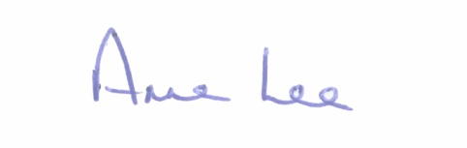
Mise le meas,

_______________
Anne Lee,
Meetings Administrator.

C L A R

1. Election of Cathaoirleach.

2. Election of Leas Cathaoirleach .

3. Fix date and time of Granard Municipal District meetings.

